Team Eywa – 2016 VAST Challenge

Kimaya Devasthali   
*School of Information*  
*Rochester Institute of Technology*Rochester, NY, United States of America  
kd1237@rit.edu

Indrani Eagapati  
*School of Information*  
*Rochester Institute of Technology*Rochester, NY, United States of America  
ie8786@rit.edu

Prathik Makthala  
*School of Information*  
*Rochester Institute of Technology*Rochester, NY, United States of America  
pm5563@rit.edu

*Abstract*—Our project addresses security concerns at GAStech Corporation's new facility on Kronos Island. Our team analyzes data from various sensors to identify patterns and potential risks. The exploration covers building floor plans, proximity cards, Hazium readings, and HVAC sensor data. Visualizations highlight anomalies in power consumption and correlations between Hazium and CO2 levels. Insights from proximity card data reveal typical work hours, late shifts, and anomalies, contributing to a safer corporate environment for GAStech

Keywords—VAST challenge, Visual Analytics, Sensor Data, Streaming Data.

# Introduction

On the fictional island of Kronos, a brand - new contemporary three-story facility has been opened for the GAStech Corporation has been constructed, all set with state-of-the-art precautionary security set up. We collect the data from the facilities various sensors and analyze the data to ensure safety and security on the premises. To maintain operational safety and effectiveness inside GAStech's corporate environment, finding and understanding patterns, abnormalities, and potential risks was made possible by this and comprehensive project. To maintain operational safety and effectiveness inside GAStech's corporate environment, finding and understanding patterns, abnormalities, and potential risks was made possible by this comprehensive project [1].

# Problem Description

This report's main objective is to perform a comprehensive examination and analysis of the data from GAStech's headquarters, with an emphasis on spotting any potentially suspicious activity and learning more about correlations and irregularities in the building's operational systems. This involves a thorough analysis and display of the sensor data, which includes HVAC systems and proximity cards. The following particular questions serve as the basis for the analysis:

* What are the typical patterns observed in the sensors - proximity cards and HVAC?
* Have there been any unusual or suspicious events?
* Any relationships observed in Building, HVAC and Employee proximity data?

# Data Exploration

## Database

The dataset prominently has building floor plans and zone

maps, csv files for the proximity sensors and proximity card data from the delivery robot called Rosie, Hazium readings for 4 zones, and HVAC sensor readings [4].

## Exploratory Analysis

Any good data science project starts with a basic exploratory analysis. We used some standard python commands such as describe, info, head, etc., to understand what attributes are at play in the database. We also studied if there were any missing data points or any extreme outliers that could be of interest. Our purpose with this step was to get to know the data more and we were satisfied [1].

# Visualizations

The VAST 2016 challenge contains over 130 different attributes and plotting them at a glance allows us to highlight the ones that are most impactful as well as useful for looking at suspicious activity [2,3].

## Power Consumption

Power Consumption, especially light power consumption can help us highlight any unusual activities based on anomalies in consumption which were in line with our other results.

## HVAC readings

We plotted various graphs such as Thermostat, Air flow, Water Supply, etc. Most of this data revealed anomalies on the dates of 7th, 8th, 11th, and 12th June, which we used in further analysis.

## Hazium vs. Carbon DiOxide

#### The following graph shows a sync in unexpected spikes in Hazium and CO2 readings, could be related to unusual activites occuring on the days of the spikes which is the 7th and 8th June.

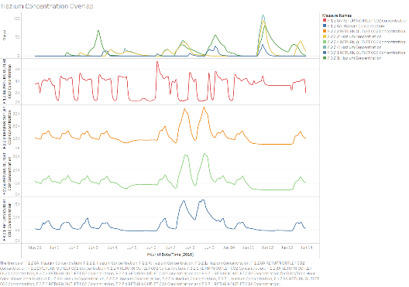

1. Hazium Vs. CO2 readings.

# Employee Patterns

Using visual analysis we can study suspicious activity as follows.



1. Employee prox card entree data prox-id vs time.

## Interesting Insights

Figure 1 is a plot that represents the proximity sensor data from fixed sensors and mobile sensors on a robot named Rosie. The plot shows the proximity sensor hits over time, with the y-axis indicating the prox-id' s of each employee and the x-axis indicating the time and day [3].

* Typical Work Hours for Employees: You observe a consistent pattern of sensor hits from 8 AM to 5 PM on weekdays. This suggests that the majority of employees are working during standard business hours.
* Late Shift for IT Department: Some employees, particularly from the IT department, seem to have a later shift starting around 4 PM.
* Night Shift for Facilities Department: There is a notable activity of very few employees from the Facilities department during the night, starting from midnight. This suggests that a small group of employees from the Facilities department may be working through the night, for tasks related to maintenance or other facility-related operations.
* Weekend Observations: There is some activity on 11 and 12th June which is a weekend. Employees Mat Bramar and Orhan Strum are in the office on the 11th and Linda Lagos is on the 12th as can be visualized in Figure 2.
* Identifying Anomalies: Executive Sten Sanjorge Jr is on the premises at the unusual time of midnight and typically works from 7 AM to 5 PM.
* Employees are issued backup prox cards if they misplace the original. Geneviere Florez has been issued 4 backup cards which indicates their carelessness or can be an anomaly that should be looked into. There is an unusual mid-night activity on 7th June as well.

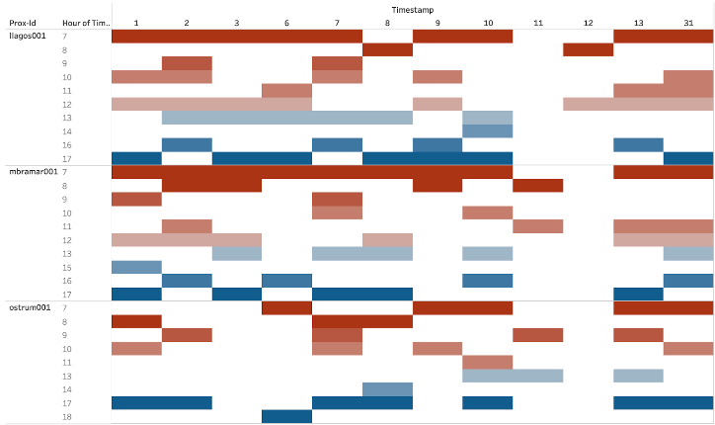

1. Weekend activity of Mat Bramar, Linda Lagos, and Orhan Strum.

## Observed Relationships

A record high of Hazium concentration was observed on 11th June which is a Saturday after a few hours of Mat Bramar and Orhan Strum’s departure from the office. A weekend activity in the office is unusual and aligned with this high concentration of hazium, this activity should be further investigated.



1. High hazium levels and unusual employee activity on June 11th.

# Conclusion

In conclusion, the visualization project utilizing the VAST 2016 Challenge Mini-challenge 2 dataset has provided valuable insights into employee movement within a building by leveraging data from multiple sensors, including proximity sensors. The comprehensive analysis aimed to identify anomalies in employee movements and establish correlations with unusual sensor readings, such as hazium levels. Through innovative visualization techniques, the project successfully uncovered patterns of abnormal employee behavior and their association with corresponding irregularities in sensor data.

##### References

1. R. J. Crouser, “VAST Challenge 2016: Streaming Visual Analytics,” Smith ScholarWorks. https://scholarworks.smith.edu/csc_facpubs/98/
2. S. Chen et al., "D-Map: Visual analysis of ego-centric information diffusion patterns in social media," 2016 IEEE Conference on Visual Analytics Science and Technology (VAST), Baltimore, MD, USA, 2016, pp. 41-50, doi: 10.1109/VAST.2016.7883510.J. Clerk Maxwell, A Treatise on Electricity and Magnetism, 3rd ed., vol. 2. Oxford: Clarendon, 1892, pp.68–73.
3. “Visual Analytics Benchmark Repository.” Accessed: Dec.11, 2023. [Online]. Available: https://visualdata.wustl.edu/varepository/VAST%20Challenge%202016/challenges/Mini-Challenge%202/
4. Accessed: Dec. 11, 2023. [Online]. Available: https://visualdata.wustl.edu/varepository/VAST%20Challenge%202016/challenges/Mini-Challenge%202/entries/KU%20Leuven/